Kadane’s Pattern

Purpose
Used to find the maximum sum of a contiguous subarray.
Idea
Keep a running sum. If the running sum becomes harmful for future results, drop it and start fresh from the current element.
Core Principle
A negative running total will only decrease any future total, so restart from the current value.
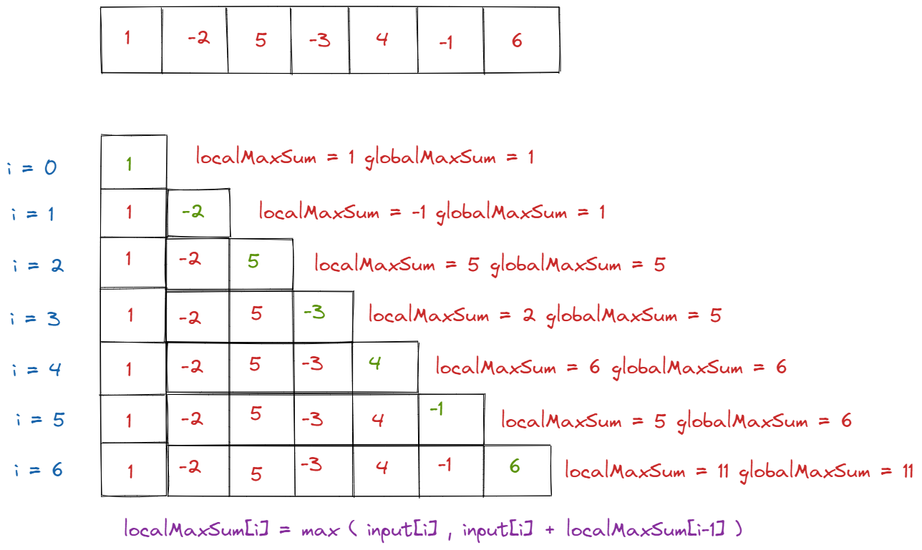
Complexity
Time: O(n)
Space: O(1)
Why it is powerful
It improves brute force solutions that often take O(n²) or O(n³) and handles negative numbers naturally.

Variants
- Standard maximum subarray
- With indices tracking
- Circular array version
- 2D matrix version
- Maximum product subarray

When to recognize it
Look for phrases such as:
- subarray
- contiguous
- maximum or minimum sum
Whenever continuing the previous sequence could make things worse, this approach is usually a good fit.

Steps
- Initialize
currentSum = nums[0]
maxSum = nums[0]
- Traverse the array from index 1 onward
Update
currentSum = max(nums[i], currentSum + nums[i])
maxSum = max(maxSum, currentSum)
- Return maxSum.
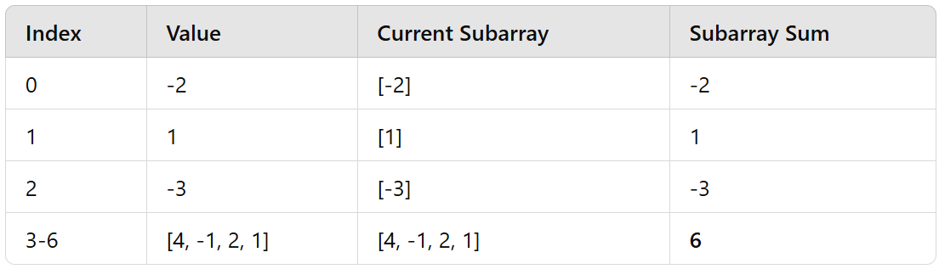

Example
Array: [-2, 1, -3, 4, -1, 2, 1, -5, 4]
Best segment: [4, -1, 2, 1]
Maximum total: 6

Common practice problems
Easy
- Maximum Subarray → 53
- Maximum Average Subarray I → 643

Medium
- Maximum Product Subarray → 152
- Maximum Sum Circular Subarray → 918
- Maximum Absolute Sum of Any Subarray → 1749
- K Concatenation Maximum Sum → 1191

Medium to Hard
- Maximum Subarray Sum After One Operation → 1746
- Maximum Alternating Subsequence Sum → 1911
- Maximum Number of Points with Cost → 1937

Hard
- Maximum Score of a Good Subarray → 1793
- Maximum Sum of 3 Non Overlapping Subarrays → 689

